

实 验 报 告
实验1-DES加解密算法编程实现
（密码安全）

课程名称： | 信息系统安全
学生姓名： | 郑宜静
学生学号： | 201630666516
学生专业： | 软件工程
开课学期： | 2018-2019 第二学期

软件学院
2019年3月

实验1- DES加解密算法编程实现
（密码学）

地 点： | B7 楼 | 333 房； | 实验台号：
实验日期与时间： | 第6周 周四晚 |  | 评 分：
预习检查纪录： | 良好 |  | 实验教师： | 陈春华

- 实验过程与结果
合理说明实验过程与结果
  - 实验代码
#include<iostream>
#include<ctime>
#include<fstream>

#define PLAIN_FILE_OPEN_ERROR -1
#define KEY_FILE_OPEN_ERROR -2
#define CIPHER_FILE_OPEN_ERROR -3
#define OK 1

using namespace std;

// 初始置换表
int IP_Table[64] = {
58,50,42,34,26,18,10,2,
60,52,44,36,28,20,12,4,
62,54,46,38,30,22,14,6,
64,56,48,40,32,24,16,8,
57,49,41,33,25,17,9,1,
59,51,43,35,27,19,11,3,
61,53,45,37,29,21,13,5,
63,55,47,39,31,23,15,7
};
// 逆初始置换表
int IP_1_Table[64] = {
40,8,48,16,56,24,64,32,
39,7,47,15,55,23,63,31,
38,6,46,14,54,22,62,30,
37,5,45,13,53,21,61,29,
36,4,44,12,52,20,60,28,
35,3,43,11,51,19,59,27,
34,2,42,10,50,18,58,26,
33,1,41,9,49,17,57,25
};

int S_Box[8][4][16] = {
{
{14,4,13,1,2,15,11,8,3,10,6,12,5,9,0,7},
{0,15,7,4,14,2,13,1,10,6,12,11,9,5,3,8},
{4,1,14,8,13,6,2,11,15,12,9,7,3,10,5,0},
{15,12,8,2,4,9,1,7,5,11,3,14,10,0,6,13}
},
{
{15,1,8,14,6,11,3,4,9,7,2,13,12,0,5,10},
{3,13,4,7,15,2,8,14,12,0,1,10,6,9,11,5},
{0,14,7,11,10,4,13,1,5,8,12,6,9,3,2,15},
{13,8,10,1,3,15,4,2,11,6,7,12,0,5,14,9}
},
{
{10,0,9,14,6,3,15,5,1,13,12,7,11,4,2,8},
{13,7,0,9,3,4,6,10,2,8,5,14,12,11,15,1},
{13,6,4,9,8,15,3,0,11,1,2,12,5,10,14,7},
{1,10,13,0,6,9,8,7,4,15,14,3,11,5,2,12}
},
{
{7,13,14,3,0,6,9,10,1,2,8,5,11,12,4,15},
{13,8,11,5,6,15,0,3,4,7,2,12,1,10,14,9},
{10,6,9,0,12,11,7,13,15,1,3,14,5,2,8,4},
{3,15,0,6,10,1,13,8,9,4,5,11,12,7,2,14}
},
{
{2,12,4,1,7,10,11,6,5,8,3,15,13,0,14,9},
{14,11,2,12,4,7,13,1,5,0,15,13,3,9,8,6},
{4,2,1,11,10,13,7,8,15,9,12,5,6,3,0,14},
{11,8,12,7,1,14,2,13,6,15,0,9,10,4,5,3}
},
{
{12,1,10,15,9,2,6,8,0,13,3,4,14,7,5,11},
{10,15,4,2,7,12,9,5,6,1,13,14,0,11,3,8},
{9,14,15,5,2,8,12,3,7,0,4,10,1,13,11,6},
{4,3,2,12,9,5,15,10,11,14,1,7,6,0,8,13}
},
{
{4,11,2,14,15,0,8,13,3,12,9,7,5,10,6,1},
{13,0,11,7,4,9,1,10,14,3,5,12,2,15,8,6},
{1,4,11,13,12,3,7,14,10,15,6,8,0,5,9,2},
{6,11,13,8,1,4,10,7,9,5,0,15,14,2,3,12}
},
{
{13,2,8,4,6,15,11,1,10,9,3,14,5,0,12,7},
{1,15,13,8,10,3,7,4,12,5,6,11,0,14,9,2},
{7,11,4,1,9,12,14,2,0,6,10,13,15,3,5,8},
{2,1,14,7,4,10,8,13,15,12,9,0,3,5,6,11}
}
};

//置换选择1
int PC_1[56] =
{
57, 49, 41, 33, 25, 17, 9,1, 58, 50, 42, 34, 26, 18,
10, 2, 59, 51, 43, 35, 27,19, 11, 3, 60, 52, 44, 36,
63, 55, 47, 39, 31, 23, 15,7, 62, 54, 46, 38, 30, 22,
14, 6, 61, 53, 45, 37, 29,21, 13, 5, 28, 20, 12, 4
};

//扩充置换表E
int E_Table[8][2] = {
{32,5},{4,9},{8,13},{12,17},{16,21},{20,25},{24,29},{28,1}
};

//置换选择2
int PC_2[48] =
{
14, 17, 11, 24, 1, 5, 3, 28, 15, 6, 21, 10,
23, 19, 12, 4, 26, 8, 16, 7, 27, 20, 13, 2,
41, 52, 31, 37, 47, 55,30, 40, 51, 45, 33, 48,
44, 49, 39, 56, 34, 53,46, 42, 50, 36, 29, 32
};//密钥压缩表

//置换函数P
int P_Table[32] =
{
16, 7, 20, 21, 29, 12, 28, 17,1, 15, 23, 26,5, 18, 31, 10,
2, 8, 24, 14, 32, 27, 3, 9, 19,13, 30, 6, 22,11, 4, 25
};//p盒置换表

// 左移位数表
int iteration_movement[16] = { 1,1,2,2,2,2,2,2,1,2,2,2,2,2,2,1 };

//密钥置换
void DES_PC1_Transform(char key[64], char temp[56]) {
for (size_t i = 0; i < 56; i++)
{
temp[i] = key[PC_1[i] - 1];
}
}

void DES_PC2_Transform(char key[56], char temp[48]) {
for (size_t i = 0; i < 48; i++)
{
temp[i] = key[PC_2[i] - 1];
}
}

// 循环左移
void DES_ROL(char data[56], int time) {
char temp[56];

//保存将要循环移动到右边的位
memcpy(temp, data, time);
memcpy(temp + time, data + 28, time);

//前28位移动
memcpy(data, data + time, 28 - time);
memcpy(data + 28 - time, temp, time);

//后28位移动
memcpy(data + 28, data + 28 + time, 28 - time);
memcpy(data + 56 - time, temp + time, time);

}

//生成子密钥
void DES_MakeSubKeys(char key[64], char subKeys[16][48]) {
char temp[56];
DES_PC1_Transform(key, temp);//PC1置换
for (int cnt = 0; cnt < 16; cnt++) {//16轮跌代，产生16个子密钥
DES_ROL(temp, iteration_movement[cnt]);//循环左移
DES_PC2_Transform(temp, subKeys[cnt]);//PC2置换，产生子密钥
}
}

//IP置换
void DES_IP_Transform(char data[64]) {
char temp[64];
for (int cnt = 0; cnt < 64; cnt++) {
temp[cnt] = data[IP_Table[cnt] - 1];
}
memcpy(data, temp, 64);
}

//IP逆置换
void DES_IP_1_Transform(char data[64]) {
char temp[64];
for (int cnt = 0; cnt < 64; cnt++) {
temp[cnt] = data[IP_1_Table[cnt] - 1];
}
memcpy(data, temp, 64);
}

//扩展置换
void DES_E_Transform(char data[48]) {
char temp[48];
for (size_t i = 0; i < 8; i++)
{
temp[i * 6] = E_Table[i][0];
temp[i * 6 + 5] = E_Table[i][1];
temp[i * 6 + 1] = data[i * 4];
temp[i * 6 + 2] = data[i * 4 + 1];
temp[i * 6 + 3] = data[i * 4 + 2];
temp[i * 6 + 4] = data[i * 4 + 3];
}
memcpy(data, temp, 48);
}

//P置换
void DES_P_Transform(char data[32]) {
char temp[32];
for (int cnt = 0; cnt < 32; cnt++) {
temp[cnt] = data[P_Table[cnt] - 1];
}
memcpy(data, temp, 32);
}

//异或
void DES_XOR(char R[48], char L[48], int count) {
for (int cnt = 0; cnt < count; cnt++) {
R[cnt] ^= L[cnt];
}
}

//S盒置换
void DES_SBOX(char data[48]) {
int line, row, output;
int cur1, cur2;
for (int cnt = 0; cnt < 8; cnt++) {
cur1 = cnt * 6;
cur2 = cnt << 2;

//计算在S盒中的行与列
line = (data[cur1] << 1) + data[cur1 + 5];//每组第一位乘2加上第六位
row = (data[cur1 + 1] << 3) + (data[cur1 + 2] << 2)
+ (data[cur1 + 3] << 1) + data[cur1 + 4];//每组第二位乘8加上第三位乘4加上第四位乘2加上第五位
output = S_Box[cnt][line][row];

//化为2进制
data[cur2] = (output & 0X08) >> 3;
data[cur2 + 1] = (output & 0X04) >> 2;
data[cur2 + 2] = (output & 0X02) >> 1;
data[cur2 + 3] = output & 0x01;
}
}

//交换
void DES_Swap(char left[32], char right[32]) {
char temp[32];
memcpy(temp, left, 32);
memcpy(left, right, 32);
memcpy(right, temp, 32);
}

//加密单个分组
void DES_EncryptBlock(char plainBlock[64], char subKeys[16][48]) {
char copyRight[48];
int cnt;

//初始置换（IP置换）
DES_IP_Transform(plainBlock);
//16轮迭代
for (cnt = 0; cnt < 16; cnt++) {
memcpy(copyRight, plainBlock + 32, 32);
//将右半部分进行扩展置换，从32位扩展到48位
DES_E_Transform(copyRight);
//将右半部分与子密钥进行异或操作
DES_XOR(copyRight, subKeys[cnt], 48);
//异或结果进入S盒，输出32位结果
DES_SBOX(copyRight);
//P置换
DES_P_Transform(copyRight);
//将明文左半部分与右半部分进行异或
DES_XOR(plainBlock, copyRight, 32);
if (cnt != 15) {
//最终完成左右部的交换
DES_Swap(plainBlock, plainBlock + 32);
}
}
//逆初始置换（IP^1置换）
DES_IP_1_Transform(plainBlock);
}

//解密单个分组
void DES_DecryptBlock(char cipherBlock[64], char subKeys[16][48]) {
char copyRight[48];

//初始置换（IP置换）
DES_IP_Transform(cipherBlock);

//16轮迭代
for (int cnt = 15; cnt >= 0; cnt--) {
memcpy(copyRight, cipherBlock + 32, 32);
//将右半部分进行扩展置换，从32位扩展到48位
DES_E_Transform(copyRight);
//将右半部分与子密钥进行异或操作
DES_XOR(copyRight, subKeys[cnt], 48);
//异或结果进入S盒，输出32位结果
DES_SBOX(copyRight);
//P置换
DES_P_Transform(copyRight);
//将明文左半部分与右半部分进行异或
DES_XOR(cipherBlock, copyRight, 32);
if (cnt != 0) {
//最终完成左右部的交换
DES_Swap(cipherBlock, cipherBlock + 32);
}
}
//逆初始置换（IP^1置换）
DES_IP_1_Transform(cipherBlock);
}

//加密文件
int DES_Encrypt(const char *plainFileName, const char *keyFileName, const char *cipherFileName) {
char plainBlock[65], cipherBlock[64], keyBlock[65];
char subKeys[16][48];
ifstream plainFile(plainFileName);
ifstream keyFile(keyFileName);
ofstream cipherFile(cipherFileName);
if (plainFile.is_open()) {
plainFile.getline(plainBlock, 65);
cout << "明文：" << plainBlock << endl;
plainFile.close();
}
else
{
return PLAIN_FILE_OPEN_ERROR;
}
//处理明文读取出错
if (keyFile.is_open()) {
//设置密钥
keyFile.getline(keyBlock, 65);
cout << "密钥：" << keyBlock << endl;
keyFile.close();
}
else {
return KEY_FILE_OPEN_ERROR;
}
//处理密钥文件读取出错
if (!cipherFile.is_open()) {
return CIPHER_FILE_OPEN_ERROR;
}

//生成子密钥
DES_MakeSubKeys(keyBlock, subKeys);

DES_EncryptBlock(plainBlock, subKeys);//加密
cout << "密文：" << plainBlock << endl;
//保存
cipherFile << plainBlock;
cipherFile.close();
return OK;
}
int DES_Decrypt(const char *cipherFileName, const char *keyFileName, const char *plainFileName) {
char plainBlock[65], cipherBlock[65], keyBlock[65];
ofstream plainFile(plainFileName);
ifstream keyFile(keyFileName);
ifstream cipherFile(cipherFileName);
if (cipherFile.is_open()) {
cipherFile.getline(cipherBlock, 65);
cout << "密文：" << cipherBlock << endl;
cipherFile.close();
}
else
{
return CIPHER_FILE_OPEN_ERROR;
}
//处理密文读取出错
if (keyFile.is_open()) {
//设置密钥
keyFile.getline(keyBlock, 65);
cout << "密钥：" << keyBlock << endl;
keyFile.close();
}
else {
return KEY_FILE_OPEN_ERROR;
}
//处理明文文件读取出错
if (!plainFile.is_open()) {
return PLAIN_FILE_OPEN_ERROR;
}

//生成子密钥
char subKeys[16][48];
DES_MakeSubKeys(keyBlock, subKeys);

DES_DecryptBlock(cipherBlock, subKeys);
cout << "明文：" << cipherBlock << endl;
//保存
plainFile << cipherBlock;
plainFile.close();
return OK;
}

int main()
{
int result;
clock_t a, b;
a = clock();
result = DES_Encrypt("src.txt", "src2.txt", "target1.txt");//加密并返回结果
if (result == -1)
{
printf("找不到明文文件或者读取出错\n");
return 0;
}
if (result == -2)
{
printf("找不到密钥文件或者读取出错\n");
return 0;
}
b = clock();
cout << "加密消耗" << b - a << "毫秒\n";

system("pause");
a = clock();
DES_Decrypt("target1.txt", "src2.txt", "target2.txt");
b = clock();
cout << "解密消耗" << b - a << "毫秒\n";
system("pause");
return 0;
}
  - 执行结果
    - 使用同一密钥，对两组明文进行加密和解密。
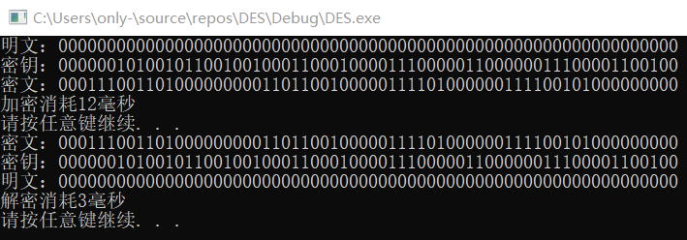
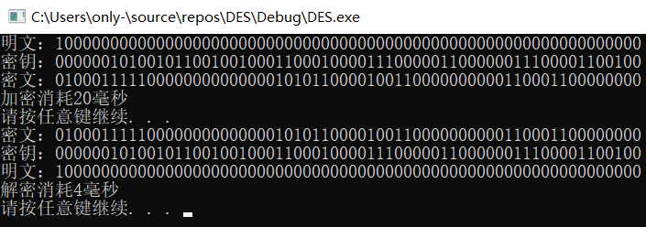
密文1：00011100 11010000 00000110 11001000 00111101 00000011 11001010 00000000
密文2：01000111 11000000 00000000 10101100 00100110 00000000 01100011 00000000
两个密文块间不同数据位的数量：21

    - 对同一段明文，使用不同密钥进行加密和解密操作。
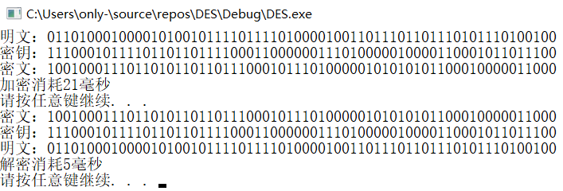
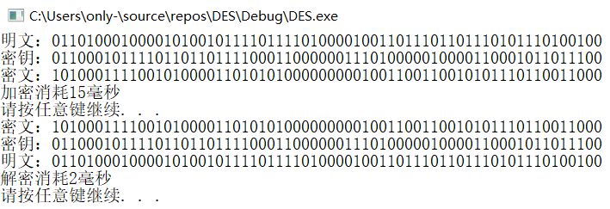
密文1：10010001 11011010 11011011 10001011 10100000 10101010 11000100 00011000
密文2：10100011 11001010 00011010 10100000 00001001 10011001 01011101 10011000
两个密文块间不同数据位的数量：24

- 回答如下问题
  - 加解密给定的数据，研究“雪崩效益”
在密码学中，雪崩效应（Avalanche effect）指加密算法（尤其是块密码和加密散列函数）的一种理想属性。雪崩效应是指当输入发生最微小的改变（例如，反转一个二进制位）时，也会导致输出的剧变（如，输出中一半的二进制位发生反转）。
严格雪崩准则（Strict Avalanche Criterion，SAC）是雪崩效应的形式化。它指出，当任何一个输入位被反转时，输出中的每一位均有50%的概率发生变化。

根据我的实验结果，我认为DES加密算法不具有雪崩效应。

